ASTRA was founded as a charter affiliate of  ATRA in 1989. ASTRA was established to represent the interests and aspirations of therapeutic recreation (TR) professionals throughout the state of Arizona. ASTRA promotes an unwavering commitment to the Therapeutic Recreation Professionals at the state and national level.  ASTRA supports ATRA’s definition of therapeutic recreation as the provision of treatment services and recreation services to persons with illnesses or disabling conditions. The primary purpose of treatment services are to restore, remediate, or rehabilitate in order to improve functioning and independence as well as reduce or eliminate the effects of illness or disability. The primary purposes of TR services are to provide recreation resources and opportunities in order to improve health and well-being.  Benefits of Membership:  - Support legislative advocacy to improve our profession  - Strong collective voice to advocate for TR  - Discounted rates to ASTRA conferences  - Quarterly newsletters  - Networking opportunities  - Professional growth  - Eligible to participate in ASTRA’s annual business meeting  - Eligible to vote on action items  - Eligible to serve as and/or vote for board members  - Contribute to the increased recognition of our profession  - Ability to post and/or search for employment opportunities using ASTRA’s website  - Post your organization’s upcoming events on the website calendar  - Keep abreast of current legislative issues as well as participate in legislative initiatives |  | 7:00 am  Registration Check-In  7:30 am: Session 1  The Power of Recreation Therapy:  Identifying Our Value, Worth, and Influence  through the Lens of the School Setting  Thea Kavanaugh, CTRS  9:00 am: Break  9:15 am: Session 2  Horse Power: Using Therapeutic Horseback Riding  as Part of a Multidisciplinary Approach  Chelsea Harden, CTRS, PATH Intl. Instructor &  Jessica Voss, CTRS, PATH Intl. Instructor  10:15 am: Break  10:30 am: Session 3  Increasing Attendance for Veterans Programs and the Importance of Creating Collective Impact  Dr. Jasmine Townsend  12:00 pm:  Lunch/Raffle/ "Innovation Station"  Expo/Awards/Health & Wellness Fair  Annual Membership Meeting  1:00 pm: Concurrent Sessions  Session 4A The Recreation Therapist in Private Practice Natalie Conca, LRT/CTRS, ATRIC, Adv. PATH Intl. Instructor Session 4B Utilizing Biofeedback Interventions in RT Settings Johanna Avilez, CTRS & Jordan Gregory, MS/P, CTRS  2:30 pm: Break  2:45 pm: Session 5  Think Outside the Box: How to Use RT as a Springboard for Creativity and Innovation  Lisa Perez, M.A., CTRS  3:45 pm: Break  4:00 pm: Session 6  Expanding TR: Implementing Your Expertise  Mikala Edwards, MPA, CTRS  5:15 pm  Social at Ruby Tuesday  4415 East Monroe Street  Phoenix, AZ 85034 |  | 90.00 ASTRA Member Full conference registration includes lunch. This option is for current Professional or Associate members of the Arizona State Therapeutic Recreation Association at time of registration.  45.00 Half-Day ASTRA Member – Includes lunch and three sessions for ASTRA members.  110.00 Non-Member – Full conference registration includes lunch but DOES NOT include membership. This option is for professionals who wish to attend but prefer NOT to become members of ASTRA. If you wish to register at the ASTRA Member rate, please join us on our website and, upon confirmation of membership, register for conference at the ASTRA Member rate.  55.00 Half Day Non-Member – Includes lunch and three sessions for professionals who wish not to join ASTRA.  25.00 ASTRA Board Member  25.00 Presenter – Full conference registration includes lunch. Speakers presenting a session at conference who wish to attend sessions may register at this reduced rate.  10.00 Student – This option is for current Student members of ASTRA to attend full conference and includes lunch. If you are not currently a Student member of ASTRA, please register on our website and, upon confirmation of membership, register for conference here.  10.00 CEU Fee to be pre-paid or paid the day of conference  20.00 ASTRA Annual Membership  Registration is OPEN!  To register and for more information go to:  astra-tr.com/event-2046074  NOTE: *Please register by Monday, April 25th to receive this rate! A $10 late fee will apply to all registrations made after that date,  INCLUDING ONSITE REGISTRATION.*  Questions  Jessi Voss  jessicavossCTRS@gmail.com |  | 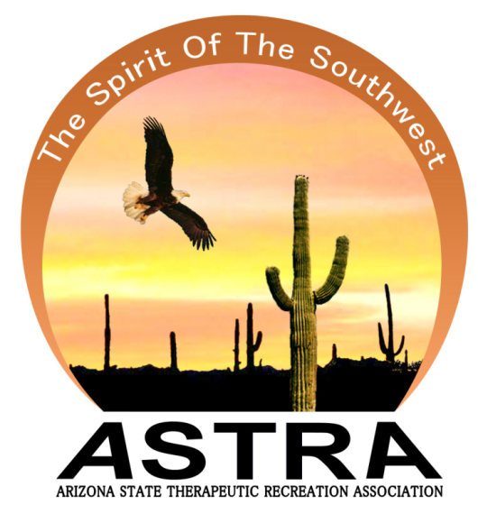  Invites you  to attend  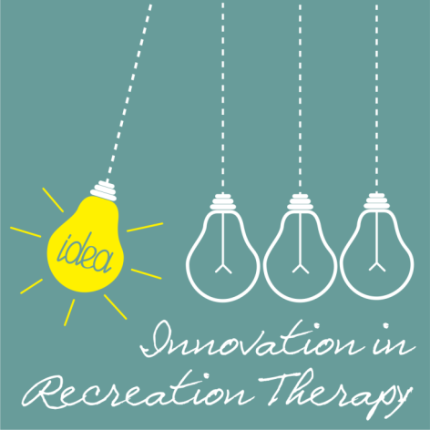  Friday, April 29, 2016  7:30 a.m. – 5:00 p.m.  Registration begins at 7:00 a.m.  Ability360 Center  (formerly Disability Empowerment Center)  5025 East Washington Street  Phoenix, Arizona 85034

